Faysal Khatri

CSC220 -- Activity 7

2017-06-26

# Part 1

## Sample Output

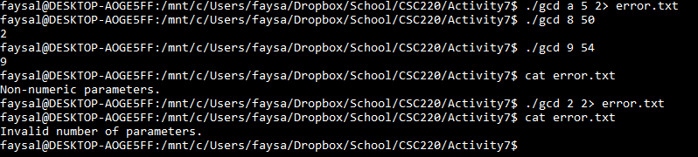

## Compilation

gcc -c gcd.c -ansi -Wall -pedantic

gcc -c activity7.c -ansi -Wall -pedantic

gcc gcd.o activity7.o -o gcd

## gcd.h

/*

This file contains gcd() header.

*/

int gcd(int x, int y);

## activity7.c

#include <stdio.h>

#include <stdlib.h>

#include <string.h>

#include "gcd.h"

int x;

int y;

int main(int argc, char **argv) {

if (argc != 3) {

fprintf (stderr, "Invalid number of parameters.\n");

return 0;

}

else {

x = atoi(argv[1]);

y = atoi(argv[2]);

if ( (x == 0) || (y == 0) ) {

fprintf (stderr, "Non-numeric parameters.\n");

return 0;

}

else {

fprintf (stdout, "%d\n", gcd(x, y));

return gcd(x, y);

}

}

}

# Part 2 - Makefile

all: gcd

gcc -c gcd.c -ansi -Wall -pedantic

gcc -c activity7.c -ansi -Wall -pedantic

gcc gcd.o activity7.o -o gcd

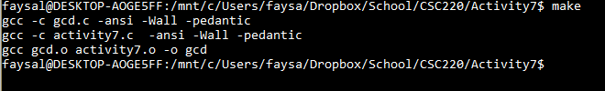

# Part 3- gdb

I was unable to get gdb to run on my Linux subsystem for Windows.

Kept getting errors when trying to run the code inside gbd.

I did compile with -g.

Looks like a memory issue.

